AI and HCI Interactions and Synergies Report

Trey Williams
University of the Cumberlands
MSAI-631-A01: Human-Computer Interaction.
Dr. Alan Dennis
September 6, 2026

AI and HCI Interactions and Synergies Report

Computers are integrated into every facet of modern life. They are no longer standalone devices confined to an office setting but are carried everywhere and, in some cases, worn as status symbols. Human-Computer Interaction (HCI) is the study of how people interact with computers and computing systems. HCI includes users, devices, and their interactions. The goal of HCI is to make those interactions effective and usable (Interaction Design Foundation, 2021). My daily interactions include using phones, computers, entertainment systems, specialized computer hardware, and artificial intelligence (AI). These interactions demonstrate how modern society as a whole is dependent on effective HCI. AI is expanding HCI because computers can increasingly understand natural language, images, voice, and other inputs rather than relying solely on traditional buttons and menus. Effective HCI has become increasingly important as computers are embedded throughout daily life, while AI and multimodal interfaces are reshaping the relationship between humans and machines from simple command-based interaction to a more collaborative experience.

Computers and HCI in My Daily Life
The first and most constant computers I personally use are my phones. I have two phones, one for personal use and another for business use. I use them for communication, email, internet access, applications, scheduling, and photographs. The primary difference is that my business phone is heavily restricted because of security requirements. Both phones use touchscreens, which provide an obvious example of an HCI interface. I interact with them through tapping, swiping, typing, voice commands, cameras, and audio. This design is human-centered because the devices meet my daily needs, capabilities, and the environments in which I use them. The goal is to adapt the device to the person rather than requiring the person to adapt to the device (Interaction Design Foundation, 2021). Smartphone interfaces are strong examples of human-centered design because they combine many complex computing functions into relatively simple, intuitive graphical controls.
The next devices I use daily are my iMac and PC. I prefer the iMac for general computing, but I prefer my Windows PC for gaming and coding. The iMac is my primary computer for work and school. I use it for research, writing assignments, communication, data analysis, and other academic activities. Although there are some limitations associated with macOS and software compatibility, most can be overcome with current applications or virtualization. I am also able to run the Windows operating system as a virtual machine on this computer. I use the integrated keyboard, a wireless mouse, and a separate monitor. This combination of hardware and software collectively forms the interface through which I interact with the underlying computer system.
Figure 1
iMac used for everyday computing and communication
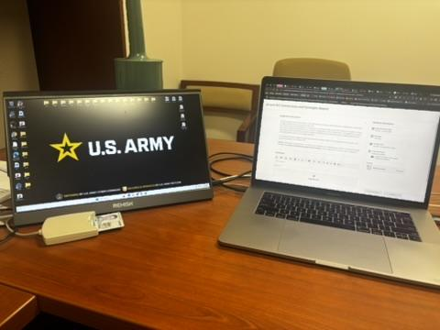
Note. I can run a Windows virtual desktop alongside macOS with no noticeable lag.
My PC is an ongoing project. I constantly upgrade the device's hardware and software as needed. I use it primarily for gaming, managing my YouTube channels, and coding. Gaming is a highly interactive form of HCI because the computer responds continuously to keyboard, mouse, controller, visual, and audio inputs. This computer must also be able to run computationally intensive programs while streaming directly to YouTube's servers, which can be very resource intensive. I also use the computer to watch media while I play games or code. When I conduct AI development, I close unnecessary applications so the computer can dedicate as much CPU, GPU, and memory capacity as possible to the model or application being developed.
I also interact with Smart TVs and Apple TV devices. Computers are now embedded in devices that people may not always think of as computers. On older televisions, or those where the built-in smart functions no longer work well, I use an Apple TV. The device contains a processor, memory, networking capabilities, applications, recommendation algorithms, and a simple graphical interface. Streaming services can also personalize content based on previous interactions. Personalization differs from manual customization because the system can automatically change the experience based on information it has about the user (Schade, 2016).

Specialized Computers and AI Development
I also use several types of specialized computers and AI development tools. GPU mining rigs are a type of computer that I regularly use for business purposes. Their primary role is to generate passive revenue for my business. The computer equipment also represents reusable hardware that can be reconfigured into AI modeling systems if needed. With the correct motherboards and supporting hardware, the GPUs can provide substantial computing resources for AI development. This creates a very different type of interaction than using my phone or iMac. I am much less concerned with a traditional consumer interface and more concerned with system performance, hardware integration, software configuration, monitoring, and computational output. These computers normally do not have dedicated displays and are instead monitored through an application on my phone. Computing systems can receive inputs, process them, and generate outputs based on the objectives of the system (Kore, 2022). When used for AI development, they similarly operate through input-output relationships and can learn those relationships through machine-learning techniques (Kore, 2022). This demonstrates how HCI changes depending on the use case, intent, and type of computer.

Figure 2
PC used for Cryptocurrency Mining
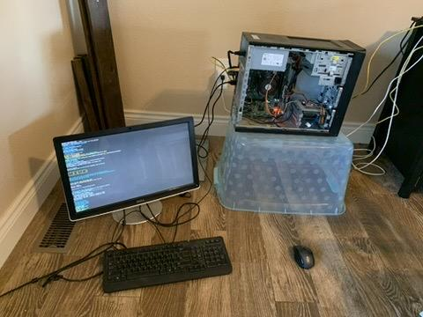

Artificial Intelligence and Human-Computer Interaction
The newest addition to my daily computing environment is the use of artificial intelligence and large language models. ChatGPT represents one of my most direct AI/HCI interactions. I have used ChatGPT as a thought companion since its release in November 2022. I also use AI tools with Microsoft applications instead of relying on traditional help functions. Another major use is learning programming commands. This approach is much easier than the way I previously searched Google for code examples. I can ask follow-up questions, clarify my intent, and refine the output interactively. I also use AI to support my writing process. I do not like relying on generated response papers, but I find AI useful for brainstorming and developing outlines that help me organize my ideas before I begin writing.
This is an example of human-machine augmentation rather than simple automation. AI can perform portions of the task, but I still need to determine whether I agree with the response and verify its validity. This demonstrates how AI can process large amounts of information, while humans are still needed to exercise judgment, interpret ambiguous information, and determine whether an answer is appropriate (Kore, 2022). Kore describes this relationship as one in which humans and machines can complement one another by applying their respective strengths. HCI is increasingly concerned with integrating human and artificial intelligence rather than treating the capabilities separately (Chignell et al., 2023). Appropriate human-centered design should enable AI to augment human decision-making while users maintain awareness, understanding, and control over the final outcome (Chignell et al., 2023). This becomes more than a technical question because it concerns how much responsibility users should delegate to AI. While an AI system may generate information quickly, the user is still responsible for determining whether the information is accurate, relevant, and appropriate to the context. Because AI systems are probabilistic and can make mistakes, humans should retain the ability to review, correct, edit, or reject AI-generated results (Kore, 2022).
Multimodal Interfaces
Recently, I have also started using agent-based multimodal interfaces such as Google Antigravity. A multimodal interface allows humans and computers to communicate through multiple forms of interaction. These can include text, speech, images, touch, and other forms of input. I can use a microphone to speak a prompt, provide text, upload a photograph or screenshot, and receive written, visual, or application-based outputs. Smartphones are also inherently multimodal because they contain multiple types of input and data-collection devices. Agent frameworks support this type of interaction because intelligent systems perceive their environments through different sensors or inputs and generate outputs in response (Kore, 2022). This is important for HCI because multimodal interfaces provide users with more natural and flexible ways to communicate with computers while making interfaces adaptable to different situations and user needs.
Conclusion
Computers are essential to my daily life. I use a combination of phones and computers for work and school, gaming and entertainment devices, and specialized computers for business and AI development. HCI determines whether all of that computing power is actually useful to the human operator. AI is also changing how HCI functions. Interaction is no longer limited to humans issuing simple commands to computers but increasingly involves systems in which people and machines collaborate to improve productivity and accomplish complex tasks. Multimodal interfaces are strengthening that relationship by allowing communication through more natural forms such as speech, images, text, touch, and sound. As AI becomes more integrated into everyday computing, effective HCI will become even more important because users must be able to understand, control, and effectively collaborate with increasingly intelligent systems.
AI Tools and Project Repository Disclosure
I used ChatGPT and Grammarly to support brainstorming and grammar revision.
I reviewed, verified, and revised all AI-assisted content and accept responsibility for the final submitted work.
Project repository: lunchtrey84/MSAI_631_REPO

References
Chignell, M., Wang, L., Zare, A., & Li, J. (2023). The evolution of HCI and human factors: Integrating human and artificial intelligence. ACM Transactions on Computer-Human Interaction, 30(2), Article 17. https://doi.org/10.1145/3557891
Interaction Design Foundation. (2021, June 14). What is human-centered design (HCD)? https://ixdf.org/literature/topics/human-centered-design
Kore, A. (2022). Designing human-centric AI experiences. Springer Nature. https://reader2.yuzu.com/books/9781484280881
Schade, A. (2016, July 10). Customization vs. personalization in the user experience. Nielsen Norman Group. https://www.nngroup.com/articles/customization-personalization/

